**What you need to know form the Lectures:**

**[However, read the entire Lectures 7, 8, 9 & 10 for terminology, etc.]**

1. Linear Planar (= 2D) Systems: *X’ = AX*

1. NONlinear Dynamical System in 1D: *x’ = f(x)*

1. NONlinear Planar (= 2D) Systems

Stability is discussed separately in the two (**hyperbolic** & **non-hyperbolic**) cases:

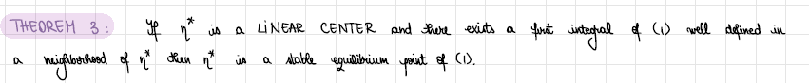

1. How to find a **First Integral** for a Planar (Nonlinear) System

1. How to find the general solution of a LINEAR system (with one off-diagonal zero)

